Unit 5: Spreadsheet Modelling
  - Assignment 2

Contents
Wireframes 2
Actual Spreadsheet 4
Reviews 5
Test Plan 6

Wireframes
Design 1
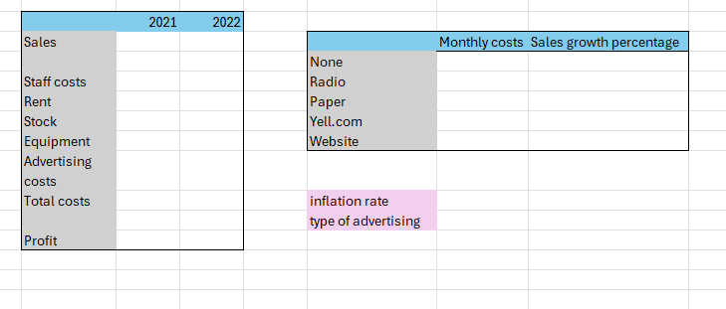
Design 2
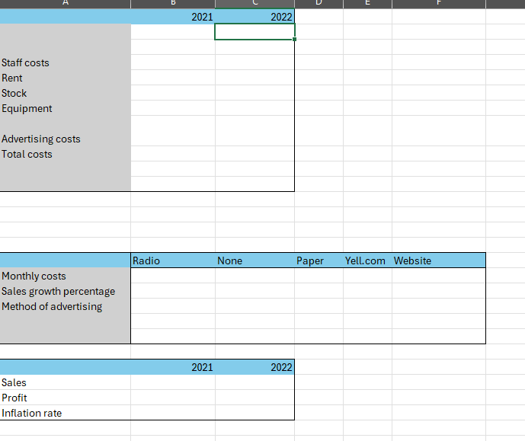
Logan McAvoy: “I do prefer design 1 greatly over design 2 as design 2 has too much empty white space. However in design one, things could be improved upon such as full borders around cells with text as well as different colour cells for different types of expenses.”
Stephanie Green: “I prefer design 1 however I feel the advertising table could be a slightly different colour from the running cost table”
According to the reviews I received, I need to make design changes to my data model such as making colour changes to my advertising table and making full borders around cells which will mean I will have to make another design of my data model, so this will be my new wireframe:
Design 1
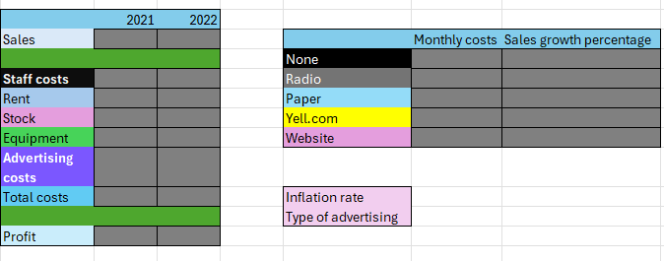

Actual Spreadsheet

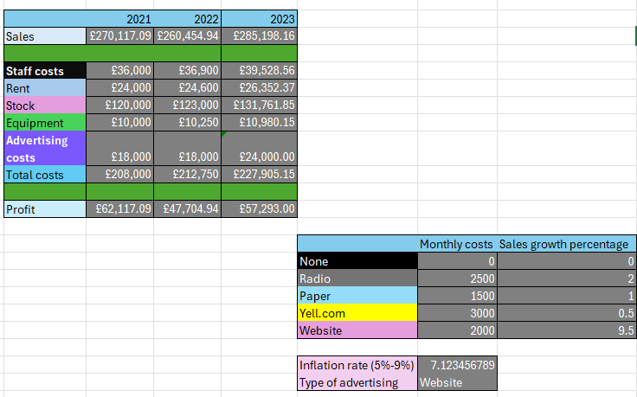Reviews
Logan McAvoy:
“Overall, I can see that the spreadsheet you have created definitely achieves it's clients goals, showing data from the previous years sales and expenses as well as the next years predicted sales and costs. One area which I really like is the inflation rate cell in which you can type in any value you want and the spreadsheet will automatically convert that to a percentage value, working it with the various costs for 2023 in an efficient manner. Another area of your spreadsheet I like is the spacing between separate areas such as the green spaces between sales, costs and profits as well as the space between the inflation rate and advertising methods area and the data table for the different advertising methods. However on the other hand, there are 2 notable problems that I can see with your spreadsheet, the first one being the choice of colours present as they seem a bit casual with their pastel nature as well as not really having much connection with the data itself when other colours would be more effective such as a bright red for total costs and green to be used for profits. Not only that but these pastel colours can look like they blend together a bit, especially on the costs area. The second possible problem that I can see with this spreadsheet is how it looks disjointed or disconnected. No background colour to be seen to connect to the separate tables together which makes them feel possibly that they are completely separate and not linked together, this could be easily avoided by applying a simple background colour around the cells of your tables in a square shape to show that they are all part of one single spreadsheet table where they all specifically work with each other.

But overall, I really do like your spreadsheet but can see that some areas do need improvement.”

Test Plan
Test No. | Test | Expected Outcome | Actual Outcome | Fix? | Fixed Outcome
1 | Profit | Shows the profit on the table by “advertising costs – sales”. | Shows the profit on the table | N/A | N/A
2 | Inflation rate | Inflation rate should change | It changes the outcome | N/A | N/A
3 | Type of advertising | The type of advertising should change | It changes the type of advertising. | N/A | N/A
4 | Inflation rate minimum and maximum | To meet its minimum and maximum requirements (so it can’t go under 5% and it can’t go above 9%) | It meets those requirements. | N/A | N/A
5 | Profit functionality | Profit should be total costs taken from sales | Advertising costs taken from sales. | Change out cell []10 to []11 | Advertising costs taken from sales.
6 | 2023 Total costs | 2023 Total costs should add all the 2023 costs together | 2023 total costs adds all the 2022 costs together, when it should just focus on 2023. | Change formula so it focuses on 2023 instead of 2022. | 2023 total costs adds all the 2023 costs together.

P7: The spreadsheet (data model) meets the client requirements because comparing the client requirements and the spreadsheet we can see that it does what the client has asked me to put in, such as applying the minimum and maximum number being 5% and 9%, predicts the effects of changing advertising methods by adding 2023 in, extracts from the attached CSV file as I've put in data from there on the spreadsheet. The design matches the client requirements as well. Therefore, the spreadsheet meets the client requirements.

